**Project Design Phase-II**

**Technology Stack (Architecture & Stack)**

|  |  |
| --- | --- |
| Date | 03 October 2022 |
| Team ID | PNT2022TMID49788 |
| Project Name | Project – Gas Leakage Monitoring and Alerting system. |
| Maximum Marks | 4 Marks |

**Technical Architecture:**

The Deliverable shall include the architectural diagram as below and the information as per the table1 & table 2

**Example: Order processing during pandemics for offline mode**

**Reference:** [**https://developer.ibm.com/patterns/ai-powered-backend-system-for-order-processing-during-pandemics/**](https://developer.ibm.com/patterns/ai-powered-backend-system-for-order-processing-during-pandemics/)

Guidelines:

1. Include all the processes (As an application logic / Technology Block)
2. Provide infrastructural demarcation (Local / Cloud)
3. Indicate external interfaces (third party API’s etc.)
4. Indicate Data Storage components / services
5. Indicate interface to machine learning models (if applicable)

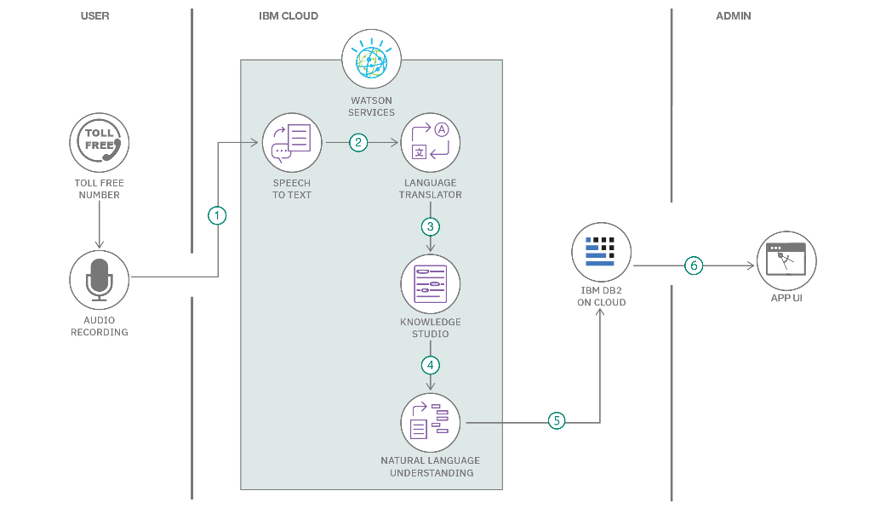

**Table-1 : Components & Technologies:**

|  |  |  |  |
| --- | --- | --- | --- |
| **S.No** | **Component** | **Description** | **Technology** |
|  | Gas Sensor-MQ6 | Used to detect LPG, Iso-butane , Propane and it detect the concentration from 200 – 10000ppm. It provide fast response. | Transforming the gas adsorption effects on the surface of the active material into a detectable signal |
|  | Arduino Uno | A Microcontroller Board based on Atmega 328P | ATMEL AVR microcontroller |
|  | Smoke detector | Automatically senses the presence of smoke, as a key indication of fire, and sounds a warning to building occupants | Radioactive material between two electrically charged plates, which ionizes the air and causes current to flow between the plates. |
|  | GSM Module | Monitoring wireless radiation through short Message Service (SMS) | TDMA, FDMA and code-division multiple access (CDMA**)**. |
|  | Database | Data Type, Configurations etc. | MySQL. |
|  | Cloud Database | Database Service on Cloud | IBM Cloudant etc. |
|  | File Storage | File storage requirements | IBM Block Storage or Other Storage Service or Local Filesystem |

**Table-2: Application Characteristics:**

| **S.No** | **Characteristics** | **Description** | **Technology** |
| --- | --- | --- | --- |
|  | Open-Source Frameworks | We use cloud for storing the data of our project | Cloud |
|  | Security Implementations | It can respond only to the corresponding admin for alerting | Encryption, IAM controls |
|  | Scalable Architecture | Make it as a device for easy to handle and fixing | Not yet determined |
|  | Availability | It is available in industries for detecting the gas levels and it will also used in chemical labouratries | IoT |
|  | Performance | It Detects the gas level perfectly and it gives notify to the corresponding admin for taking immediate action | GSM |

**References:**

[**https://c4model.com/**](https://c4model.com/)

[**https://developer.ibm.com/patterns/online-order-processing-system-during-pandemic/**](https://developer.ibm.com/patterns/online-order-processing-system-during-pandemic/)

[**https://www.ibm.com/cloud/architecture**](https://www.ibm.com/cloud/architecture)

[**https://aws.amazon.com/architecture**](https://aws.amazon.com/architecture)

[**https://medium.com/the-internal-startup/how-to-draw-useful-technical-architecture-diagrams-2d20c9fda90d**](https://medium.com/the-internal-startup/how-to-draw-useful-technical-architecture-diagrams-2d20c9fda90d)